In the following code, the server sends the current time string to the client:

# server.py

import socket

import time

# create a socket object

serversocket = socket.socket(socket.AF_INET, socket.SOCK_STREAM)

# get local machine name

host = socket.gethostname()

port = 9999

# bind to the port

serversocket.bind((host, port))

# queue up to 5 requests

serversocket.listen(5)

while True:

# establish a connection

clientsocket,addr = serversocket.accept()

print("Got a connection from %s" % str(addr))

currentTime = time.ctime(time.time()) + "\r\n"

clientsocket.send(currentTime.encode('ascii'))

clientsocket.close()

Here is the summary of the key functions from [socket - Low-level networking interface](http://docs.python.org/3/library/socket.html):

1. **socket.socket()**: Create a new socket using the given address family, socket type and protocol number.
2. **socket.bind(address)**: Bind the socket to **address**.
3. **socket.listen(backlog)**: Listen for connections made to the socket. The **backlog** argument specifies the maximum number of queued connections and should be at least 0; the maximum value is system-dependent (usually 5), the minimum value is forced to 0.
4. **socket.accept()**: The return value is a pair **(conn, address)** where **conn** is a new socket object usable to send and receive data on the connection, and **address** is the address bound to the socket on the other end of the connection. At **accept()**, a new socket is created that is distinct from the named socket. This new socket is used solely for communication with this particular client. For TCP servers, the socket object used to receive connections is not the same socket used to perform subsequent communication with the client. In particular, the **accept()** system call returns a new socket object that's actually used for the connection. This allows a server to manage connections from a large number of clients simultaneously.
5. **socket.send(bytes[, flags])**: Send data to the socket. The socket must be connected to a remote socket. Returns the number of **bytes** sent. Applications are responsible for checking that all data has been sent; if only some of the data was transmitted, the application needs to attempt delivery of the remaining data.
6. **socket.colse()**: Mark the socket closed. all future operations on the socket object will fail. The remote end will receive no more data (after queued data is flushed). Sockets are automatically closed when they are garbage-collected, but it is recommended to close() them explicitly.

Note that the **server** socket doesn't receive any data. It just produces **client** sockets. Each **clientsocket** is created in response to some other **client** socket doing a **connect()** to the host and port we're bound to. As soon as we've created that **clientsocket**, we go back to listening for more connections.

# client.py

import socket

# create a socket object

s = socket.socket(socket.AF_INET, socket.SOCK_STREAM)

# get local machine name

host = socket.gethostname()

port = 9999

# connection to hostname on the port.

s.connect((host, port))

# Receive no more than 1024 bytes

tm = s.recv(1024)

s.close()

print("The time got from the server is %s" % tm.decode('ascii'))

The output from the run should look like this:

$ python server.py &

Got a connection from ('127.0.0.1', 54597)

$ python client.py

The time got from the server is Wed Jan 29 19:14:15 2014

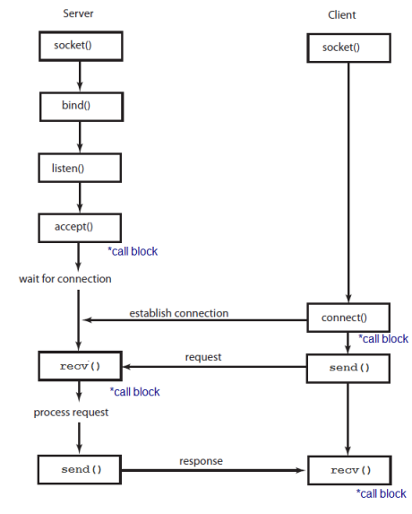

Note from <http://docs.python.org/2/howto/sockets.html>:

"If you need fast **IPC** between two processes on one machine, you should look into whatever form of shared memory the platform offers. A simple protocol based around shared memory and locks or semaphores is by far the fastest technique."

"If you do decide to use **sockets**, bind the 'server' socket to 'localhost'. On most platforms, this will take a shortcut around a couple of layers of network code and be quite a bit faster."

In Python 3, all strings are **Unicode**. For more info, visit [Character Encoding](http://www.bogotobogo.com/python/python_files.php#character_encoding).  
So, if any kind of text string is to be sent across the network, it needs to be encoded.This is why the server is using the **encode('ascii')** method on the data it transmits. Likewise, when a client receives network data, that data is first received as raw unencoded bytes. If you print it out or try to process it as text, we're unlikely to get what we expected. Instead, we need to decode it first.This is why the client code is using **decode('ascii')** on the result.

Echo Server

This is an echo server: the server that echoes back all data it receives to a client that sent it.

Server:

# echo_server.py

import socket

host = '' # Symbolic name meaning all available interfaces

port = 12345 # Arbitrary non-privileged port

s = socket.socket(socket.AF_INET, socket.SOCK_STREAM)

s.bind((host, port))

s.listen(1)

conn, addr = s.accept()

print('Connected by', addr)

while True:

data = conn.recv(1024)

if not data: break

conn.sendall(data)

conn.close()

Client:

# echo_client.py

import socket

host = socket.gethostname()

port = 12345 # The same port as used by the server

s = socket.socket(socket.AF_INET, socket.SOCK_STREAM)

s.connect((host, port))

s.sendall(b'Hello, world')

data = s.recv(1024)

s.close()

print('Received', repr(data))

Note that the server does not **sendall()/recv()** on the socket it is listening on but on the new socket returned by **accept()**.

$ python echo_server.py

('Connected by', ('127.0.0.1', 57750))

$ python echo_client.py

('Received', "'Hello, world'")